***How business Intelligence used by organisation can improve operations***

**Introduction -**

This report will be Conduct research to identify specific examples of organisations that have used business intelligence tools to enhance or improve operations. It will also discuss the impact of business intelligence tools and technologies for effective decision-making purposes and the legal/regulatory context in which they are used.

**How WFP is using Business Intelligence to reach their target audience Software can Help you Increase Operational Efficiency**

Business Intelligence software is an essential tool for analysing the strengths and weaknesses of your company. From inventory management to accounting, to customer intelligence and beyond, there are many ways in which you can use BI software to inform your decision-making, increase operational efficiency and gain a competitive edge.

BI, or Business Intelligence, is a programme that has been specifically designed to evaluate all the data a business needs in order to gain a better understanding of the strengths and weaknesses of the enterprise. That's how Webopedia describes it, at least.

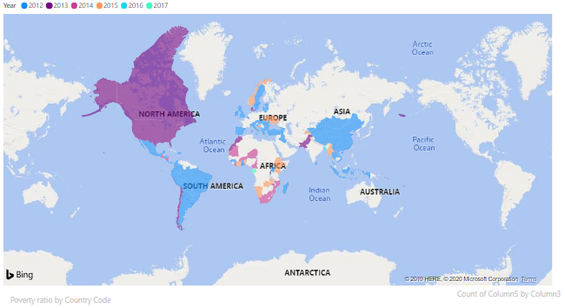

**Data Visualisation-**

Businesses tend to collect massive amounts of data. These data can be anything from inventory to customer purchase habits and everything in between. This data does not really mean a lot on its own. Nevertheless, once all this data has been processed by the BI app, it is turned into useful and valuable knowledge that is crucial to the success of any organisation.

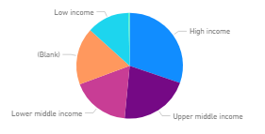

**BI Software -**

There are different types of BI applications that are useful at different things. Some are better at inventory management, while others can tackle financial statistics and the like. The kind of BI programme you need will depend on the type of company you're in and what you need to do. Nevertheless, whichever sort you might need, you can easily find the top-ranked BI systems and get out of there.

They can choose from corporate dashboards and scorecards to OLAP tracking (online information processing), ad hoc or tactical monitoring, modelling, data mining, and business intelligence tools.

**Going in it Alone by yourself -**

If you have a one-person startup business, you might be able to do it on your own for a while. When the business grows, though, more and more data can inevitably continue to collect. The truth is, no matter how many big data books you read, you will ultimately require resources like BI software to make the data function for you as your business grows.

Business Intelligence software provides a broad range of tools, methodologies and frameworks that allow businesses to collect data from external and internal sources, prepare it for review, build and then execute data queries, and then produce reports, data visualisation, and more easily accessible to policy makers at the company level as well as to staff at the organizational level.

**Benefits -**

There are a number of potential advantages of BI systems that include strengthening and speeding the decision-making process, transforming the internal business processes and growing the operational efficiency to drive new sales and achieve a competitive edge against competing companies. In fact, BI programmes will help the organisation recognise market trends and detect business issues that need to be tackled.

Data BI uses may include such items as new data that is gathered as it is currently produced, as well as historical information. It allows both the operational and the political decision-making systems to be facilitated.

Initially, the BI applications were primarily used by mainstream data analysts as well as by a few other IT practitioners who would conduct the research and then generate reports of their application findings for end-users. Nevertheless, company employees and ceos are now using this type of software themselves, and this is partly due to the growth of self-service data exploration and BI systems.

**What can B.I Include and improve operations in an organisation -**

Such industry experts draw on a range of persuasive advantages that span across different business functions — from advertisement and advertising and customer service.

**1. Determine the ROI of your marketing strategy.**

According to **Vicky Llerena, CEO of Social Vibes Media** "In a market saturated with applications, social media platforms, measurement software, and pay-per-click ads, business intelligence is critical in helping small businesses find out whether the marketing strategy they have invested in yields ROI (return on investment). Business intelligence can be converted into empirical documents where business may base decisions on solid analysis, evidence, and information, rather than emotion, belief, or gut instinct. How do you feel there's something working? Documents can tell you a much bigger storey than you could have expected.”

**2. Derive knowledge from a sea of data.**

According to **Someshwar Chidurala, Digital Marketing Analyst, Orchestrate Technologies, LLC** "Business intelligence now is more relevant than ever. Ninety percent of the data that exists today around the globe has been generated in the last two years only. Moving ahead, the pace of data production is only increasing. The main reason for this is the proliferation of social media channels and the growing number of users disseminating data at breakneck speeds. What is the meaning of all that sea of info without a lot of insightful information? Businesses consider it a conundrum to derive concrete lessons from all this. This is where business intelligence is starting to come in. It adds meaning to the chaos of all that data petabytes are flying about. It is the art of deriving knowledge from all the business processes to help enterprises gain a head start to better understand customer needs and market dynamics. Improving performance, delivering on customer promises, and building long-term customer relationships are some of the benefits of BI."

**3. Understand what drives revenue for your business.**

According to **Zachary Reed, Manager, Marketing and Communication, Triumph Bancorp** "Although business intelligence can be a very broad term, it is for me to know exactly what is going to drive revenue for your company. To know that is to know who the end user is, what affects their choices and how they ingest their information. In today's market, there are thousands of sources that distribute information, and not everyone can absorb it all. Business intelligence is to know where and how (media outlets and through posts, images, advertisements, podcasts, etc.) the ideal customer absorbs their content, what causes them to buy and subscribe, and to carry out a plan to take advantage of that awareness.”

**4. Personalize your sales strategy and anticipate objections.**

According to **Curtis Boyd, CEO/Founder, Future Solutions Media** "Business intelligence is a better understanding of the other market you are trying to work with in any way. Typically, sales teams are investigating that information to be prepared for complaints relevant to the company's case. It's particularly useful to know if the business you're trying to sell is cutting budgets, rising employee attrition, reporting lower sales numbers, combining or selling to rivals at lower prices. Apart from an in-depth business intelligence, there are many other things to look for in an organisation to determine its fitness. This research is going to be easier if the company is publicly traded, if not, you are up to your own devices.

If you're part of a sales department, it's a very great idea to do market analysis and tailor a sales strategy, not only will you be better informed for their challenges, but you will be more realistic about knowing the difficulties that this client will have to overcome in order to go forward with the deal.

The sales team should have a long list of things to check at, see if the client is a good sales applicant. The more items on the checklist that match up, the more leverage you've received from your business intelligence you can use to help them understand how amazing a choice they are.”

**5. Avoid bottlenecks and problems in a fragile market.**

According to **Rick Armstrong, CPA and Founder, QB Pro Consulting, Inc.** "Business intelligence is important to both management and shareholders, as it offers information into the true health of a company that are not readily available through profit and loss statements. There are a variety of BI tools available on the market today that interact with your accounting software. The key is to understand what is right for your type of business, because each has its own pros / cons and apps. Business intelligence is not just about monitoring KPIs (key performance indicators) once a month or every fifth. BI involves modelling to prevent bottlenecks and provide a perfect timing for decision-making, such as acquisitions or new hires. An easy-to-read report that is checked regularly will help you get more educated and avoid problems in a very competitive industry.”

**Evaluation of WFP research further to explore the legal, security of DATA.**

**Ethnic poverty discrimination -**

The data could be manipulated to be bias amongst a specific demographic of people which can affect the way WFP takes action and prioritise which country to cater to and impact the specific demographic who were in poverty in the first place.

**Data security implementation -**

To protect data from any manipulation which will alter the decision making process of WFP data must be secured using access rights privileges which will ensure data to be safely secured. This should stop data from being affected or manipulated to benefit the imposter in their way. This will give the WFP a better understanding on what decision making strategies can be taken to efficiently cater to a certain demographic.

**Data misrepresentation -**

The way data is represented can affect the perspective of the society, data can be changed or altered to be perceived to the audiences. This can lead to false representation of data and can cause serious problems in the long run. To ensure that data is not mis-prepresented proper measures should be taken to protect the access rights that is given the privilege.

**Data Access Rights -**

Playing with numbers can change the outcome of the way the WFP takes action. This is where WFP get access rights to data privileges to run the business process, and not giving permissions to any other sources which will insure data to be secure

**Conclusion -**

In conclusion, this report will be Conduct research to identify specific examples of organisations that have used business intelligence tools to enhance or improve operations. It will also discuss the impact of business intelligence tools and technologies for effective decision-making purposes and the legal/regulatory context in which they are used.

**References -**

Innovation Management. (2020). *How Business Intelligence Software can Help you Increase Operational Efficiency | Innovation Management*. [online] Available at: https://innovationmanagement.se/2017/02/09/how-business-intelligence-software-can-help-you-increase-operational-efficiency/ [Accessed 26 Jan. 2020].

Schmidt, S. (2020). *10 Ways Business Intelligence Can Help Your Organization*. [online] Blog.marketresearch.com. Available at: https://blog.marketresearch.com/10-ways-business-intelligence-can-improve-your-organization [Accessed 26 Jan. 2020].